Model View Controller (MVC)

MVC:
- A software architecture pattern which divides an application into three kinds of components and defines the interactions between them.

- A compound design pattern made up of the Composite, Strategy, and Observer patterns.

Model:
- Model holds all the data, state and application logic.
- Sends notifications of its state changes to registered observers (Controller and View).
- Observable to View and Controller.

View:
- View gives us a visual representation of the model.
- Usually gets the state and data it needs to display directly from model.
- Composite of view components.

Controller:
- Takes user input/request and figures out what it means to the model and also updates view to change the state.
- Acts as a mediator.
- Implements the strategy for one or more view objects.

Aspire:
- Separation of Concerns (SoC): Separating a program into distinct sections.
- Code Re-Usability: Multiple views on single model.

Pros:
- Supports multiple views: Because the view is separated from the model and there is no direct dependency from the model to the view, the user interface can display multiple views of the same data at the same time.
- Accommodates change: User interface requirements tend to change more rapidly then business logic. Because the model doesn't depend on the views, adding new types of views to system generally doesn't affect the model, hence scope of change is confined to the view.

Cons:
- Complexity: As it introduces new levels of indirection and therefore increases the complexity of the solution slightly and becomes difficult to debug.
- Cost of frequent updates: If the model undergoes frequent changes, it could flood the views with update requests. And therefore it is important to keep the view in mind when coding the model.

MVC As A Compound Design Pattern

Traditional version of MVC as a compound pattern:

Composite:
- Pattern Defined: Allows you to compose objects into tree structures to represent part-whole hierarchies. Lets clients treat individual objects and compositions of objects uniformly.
- View uses Composite Pattern internally to manage window's components (text, check box, drop-down list, button, etc.,). Each display component is a composite node (like a window) or a leaf node (button). When the controller tells the view to update, it only has to tell the top view component, and the Composite takes care of the rest.

Strategy:
- Pattern Defined: Defines a family of algorithms, encapsulates each one, and makes them interchangeable. Strategy lets the algorithm vary independently from clients that use it.
- Views and Controllers implement Strategy Pattern: Controller is the behavior of the View and can be easily exchanged with another Controller if you want different behavior.

Observer:
- Pattern Defined: Defines a one to many dependency between objects so that when one object changes state all of its dependents are notified and updated automatically.
- Model uses Observer Pattern to keep views and controllers updated on the latest state changes. Here, the Model is observable and the Views (and also Controllers) are observers.

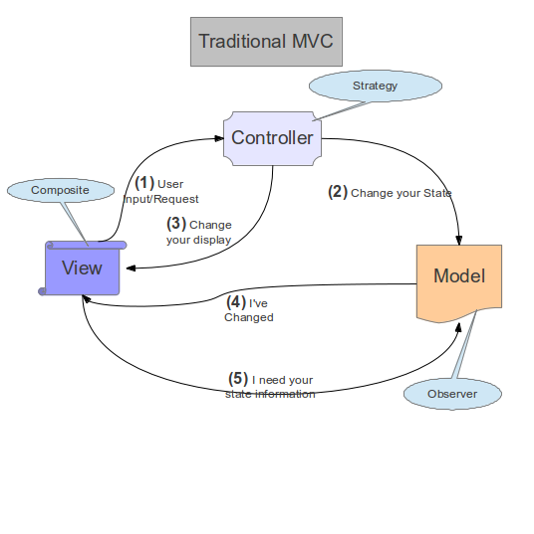

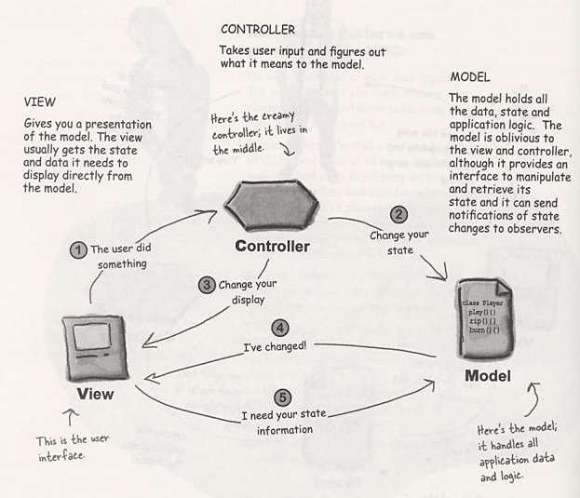

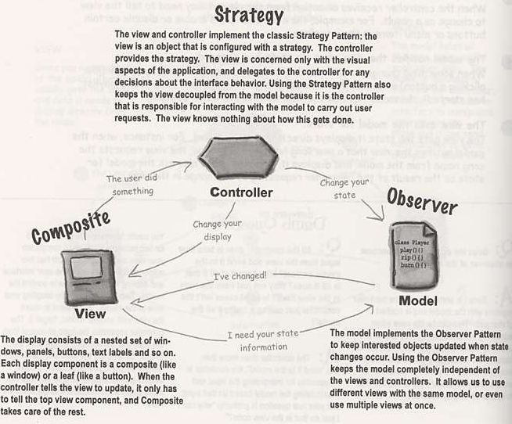

Model 2 MVC (MVC and the Web/JEE)

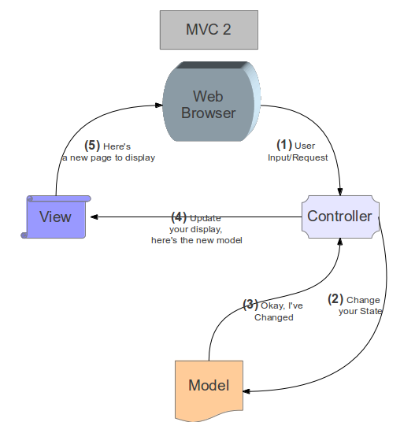

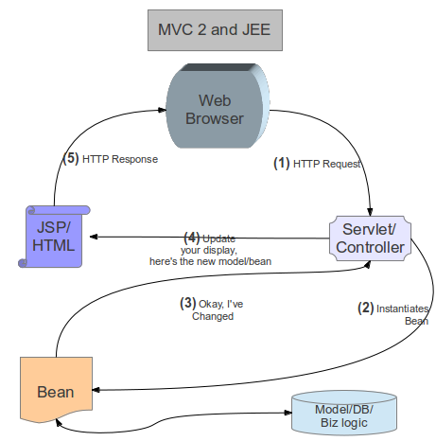

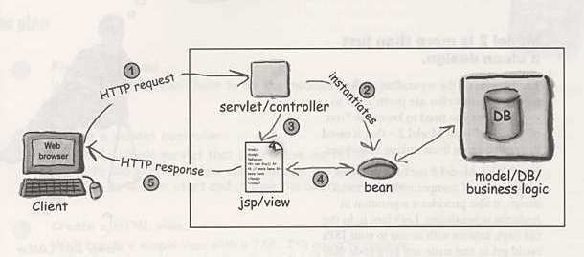

Model 3 MVC

